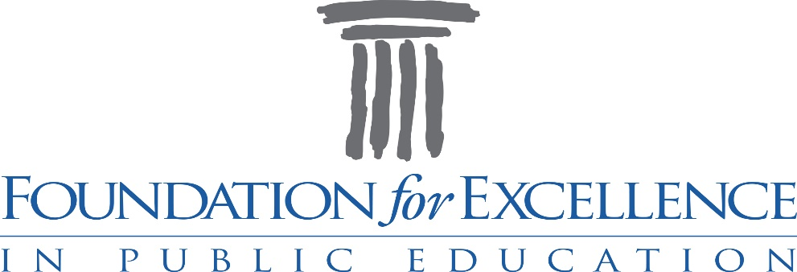

Award Nominees’ Tea

Monday, April 8th, 2019, 4:00 p.m.

T r u m p s a t S o u t h M i l l e d g e
A t h e n s, G e o r g i a

Thomas H. Whitehead Chair for Teachers of Science ($1250 for 2 years)
Ann M. Schindel Chair for Teachers of Mathematics ($1250 for 2 years)
Cardee Kilpatrick Chair for Middle School Teachers ($1250 for 2 years)
Martha Comer Chair for Teachers of Languages ($1250 for 2 years)
Kathryn H. Hug Instructional Leadership Award ($1250 for 2 years)
Joan D. Humphries Excellence in Teaching Award ($500 for 2 years)
Ken Sherman Double Century Excellence in Teaching Award ($500 for 2 years)
Seasoned Teacher Award ($500 for 2 years)
Freida M. Thomas Teacher of Promise Award ($500)
Michael P. Horvat Secondary Coaches’ Award ($500)
Bertis Downs District Services Award (2 at $500)
Howard B. Stroud Community Service Award ($500)

This event is made possible by the generosity of

Synovus Bank
Ron Schwartz and Trumps Catering
Michael Ripps and Jittery Joe’s
Shane Todd and Chick-fil-A
Keith and Catherine Neace and Barberitos
Jason Milburn and Outback Steakhouse

“Out of the public school grows the greatness of a nation.”
M a r k T w a i n

Program

Welcome
Mandy Bernt
FFE President Elect

FFE Highlights
Joan D. Humphries
Retired CCSD Principal and Former FFE Trustee

Introduction of Honorees
FFE Trustees

Introduction of 2019 C. Thomas Poss STAR Teachers
Demond Means
CCSD Superintendent
Kimberly Takagi, Cedar Shoals HS
Claude Gonzalez and Ginger Lehmann, Clarke Central HS

FFE Updates
Vicki Keenan
FFE Trustee

Closing Comments
C.J. Amason
FFE Executive Director

2019 FFE Nominees

Sook Jin Abbott
Chris Aiken
Melissa Albano
Ian Altman
Brent Andrews
Peggy Bailey
Kisha Bailey
Chris Batson
Annie Birdsong
Susan Bolen
Auburn Bolton
Keamber Booker
Annie Bradberry
Mary Bradbury-Bailey
Suzette Braden
Brian Bray
Alyson Brice
Cameron Brooks
David Brownlee
Cassandra Burch
Jeffrey Burton
Joyce Butler
Shundra Caldwell
Janet Campbell
Zadian Carey
Heather Cash
India Chatmon
Haley Cinereski
Sara Clarke
Lindsay Coleman-Taylor
LeAnna Cuevas
Bianca Culver
Courtney Cunningham
Krista Dean
Rachel Dunston
Danielle Edge
Franchesca Ferguson
Natalia Ferrando
Washonda Foote
Taylor Fourman
Alycia Garth
Lyndsay Goeckeritz
Allyson Griffith
Rebecca Hall-Barrett
Khadijjah Hannah
Kenneth Hobbs
Jacqueline Holland
Beth Holliday
Donald Hollman
Jacie Hortman
Audrey Hughes
Chris Hulse
Nicholas Hussain
Chinyere Ikedionwu
Shawanna Jones
Heather Julian
Savanna Kelley
Jennifer Learnard
Stefanie Legato
Blake Lewis
Sarah Lowing
Megan Makin
Angela Manous
Jaime Marshall
Samantha Massey
Karen McDonald
Stephanie McKee
Meghan McNeeley
Marco Messori
Margaret Ellen Mixon
Andrea Mooney
Ashley Morgan
Kanesha Morman
Marilyn Murphy
Ashley Neal
Valerie Oxford
Sara Parrish
Melissa Perez-Rhym
Janice Phillips
Cherrelle Pullen
Tina Pullen
David Ragsdale
Stephanie Rary
Justin Rebitch
Karen Rhodes
Lauren Ritter
Amy Roark
Justin Robertson
Becky Ross
Jennifer Scott
Mollie Sherman
Heather Sitler
Fonda Slongo
Summer Smith
Jo Smith
Janet Stephens
Joan Stevens
Polly Strange
Virginia Suggs
Elijah Swift
Kristen Swindle
Katy Tedford
L’Dreco Thomas
Rebecca Thorpe
Andrea Tillman
Caitlin Tucker
Tiffani Turner
Sarah Britton Vaughn
John Walker
Tonya Ward
Shannon Watkins
Bernita White
Kim Whitehead
Jessica Wilcox
Heather Williams
Carla Williams
Teresa Williams
Hallie Williamson
Hope Zimmerman

FFE Board of Trustees

Josh Podvin, President
Mandy Bernt, President-Elect
Emily Boness, Secretary
Glenn Leavell, Treasurer
Jared Bybee, BOE Representative
Mary Dixon Garrison, Past President

Wanda Culpepper
Pam Ezekiel
Ani Fischer
Vicki Keenan
Julie Moon
Casey Mull
Susan Williams
Wanda Wright

Ex Officio:
CJ Amason, Executive Director
Mary Wickwire, CCSD Liaison
Paul Matthews, Webmaster
Rob Grabowski, UGA MBA Fellow

